Adventist University of Central Africa
INTELLIGENT MARKET RESEARCH AND PRODUCT INNOVATION PLATFORM
CASE STUDY: AFRICA OLLEH SERVICES LTD (AOS)
A topic for a final year project, submitted to the faculty of Information Technology for approval
By
Muhorakeye Chrissie, #21956
Majoring in
Software Engineering
July, 2024

PART I
AS IS PROCESS MODEL
Introduction
AOS Ltd, established in 2014, is a Rwandan ICT service provider and operator of the National Data Center. As a consolidated affiliate of Korea Telecom, AOS Ltd is committed to leveraging advanced technologies to drive efficiency and innovation. The collaboration between Rwanda and Korea Telecom aims to position Rwanda as a regional ICT hub, fueling economic growth and enabling effective business service delivery.
AOS Ltd operates on a business model that encompasses a wide range of services. These include data center services such as colocation hosting and cloud hosting, web and mail hosting, IT consulting and integration, network security, and software product development. The focus of this research is on IT consulting and integration, highlighting AOS's use of advanced AI-driven tools to optimize clients' IT infrastructure and drive innovation.
The primary problem with the current IT consulting and integration model is its reliance on outdated methods for gathering and analyzing data, predicting trends, managing risks, and utilizing customer feedback. These traditional approaches often result in slower response times, missed opportunities, and fragmented risk management, leading to inefficiencies and suboptimal client outcomes. By integrating InnovaSuite, an AI-driven platform, AOS Ltd can transform its consulting services with real-time market research, predictive analytics, comprehensive risk assessments, and advanced sentiment analysis tools.
In conclusion, AOS Ltd endeavors to elevate Rwanda's status as a regional ICT hub by offering a diverse range of services, including data center solutions, IT consulting, network security, and software product development. Focusing on enhancing technological infrastructure and fostering business growth, AOS can overcome the challenges posed by outdated methods and ensure the delivery of superior services that surpass customer expectations. Through the integration of InnovaSuite, AOS Ltd will streamline and optimize its IT consulting and integration process, leading to increased efficiency, agility, and innovation.

Modeling the System
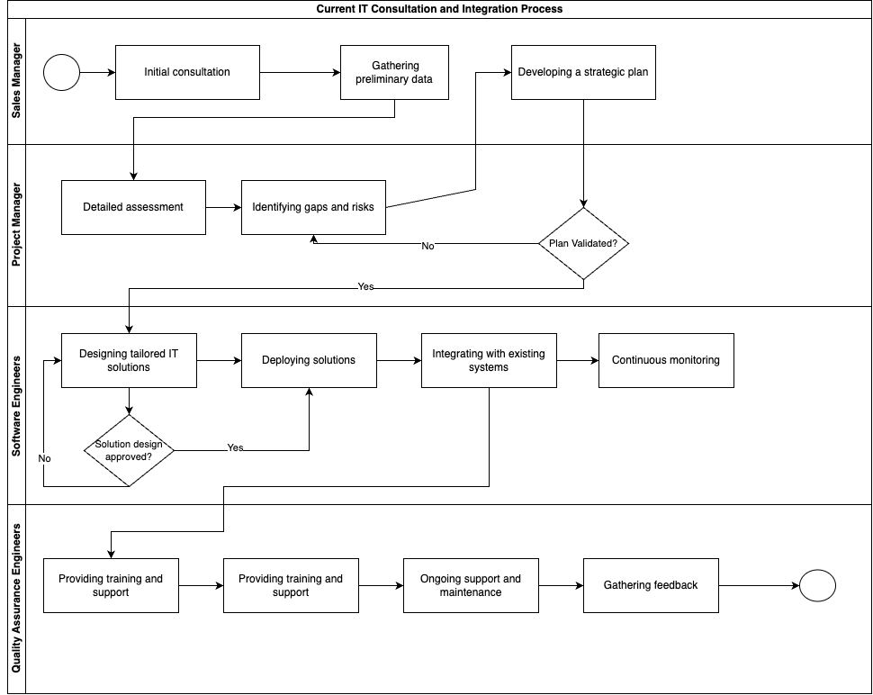
Figure 1: AOS IT Consultation and Integration Process Model
1st Step: The Sales Manager initiates the process by engaging in an initial consultation with the client. This involves understanding the client’s needs and gathering high-level information about their current IT infrastructure.
2nd Step: The Project Manager conducts a comprehensive assessment of the client’s IT infrastructure. This involves analyzing the preliminary data collected to understand the current system’s performance and identifying gaps and risks.
3th Step: Software Engineers design tailored IT solutions based on the validated strategic plan. This involves creating detailed specifications and ensuring that the solutions align with client requirements and industry best practices.
4th Step: Quality Assurance Engineers continuously monitor the performance of the integrated IT systems. This involves tracking system performance, identifying issues, and ensuring the ongoing reliability and effectiveness of the IT solutions.

PART II
PROBLEMS WITH THE CURRENT SYSTEM
Performance
Throughput:
- Manual data collection processes are time-consuming, creating bottlenecks that reduce overall project throughput.
- Reliance on manual processes like emails and phone calls results in fragmented workflows, slowing down project progression and reducing throughput.
Response Time:
- The lack of advanced data analytics tools causes delays in processing and analyzing data, impacting the response time for developing strategic plans.
- Manual methods for gathering and integrating customer feedback are slow, leading to delays in responding to client needs and making necessary adjustments.
Information
Input:
- The current system relies heavily on manual data entry during the initial consultation and preliminary data gathering, which is prone to errors and inconsistencies.
- There is a lack of integration with diverse data sources, resulting in incomplete or outdated information being used for assessments and planning.
Output:
- The process of generating reports and strategic plans is slow due to manual compilation and analysis, leading to delays in delivering actionable insights to clients.
- Outputs such as reports and recommendations are often inconsistent in format and quality, making it difficult for clients to interpret and act on the information efficiently.

Storage:
- There is no system in place for real-time updates to stored data, resulting in potential discrepancies and outdated information being used for decision-making.
- Retrieving stored information for reporting and analysis is time-consuming and often requires manual effort to locate and compile data from various sources.
Economics
- The reliance on manual processes and fragmented workflows leads to increased labor costs and inefficiencies, driving up the overall operational expenses.
- The current system’s inefficiencies and lack of automation limit the ability to scale operations cost-effectively, constraining growth potential and profitability.
Control
- The absence of integrated tools and centralized data storage makes it difficult to maintain comprehensive oversight and control over the entire IT consulting and integration process.
- Manual and fragmented workflows lead to variability in how processes are followed, resulting in inconsistent adherence to best practices and standards across different projects.
Efficiency
- The reliance on manual data entry, analysis, and communication slows down the entire workflow, leading to significant inefficiencies and delays in project completion.
- Fragmented workflows and decentralized data storage result in redundant tasks and duplication of efforts, further reducing overall operational efficiency.
Service
- The manual and inefficient processes lead to delays in responding to client inquiries and requests, negatively impacting customer satisfaction and service quality.
- The lack of a streamlined system for gathering and analyzing customer feedback results in missed opportunities to improve services and address client concerns promptly.

